**Seat Position Effects on Metabolic Energy Expenditure Rate While Cycling**

*ME 329 2021: Specialized Team*

**1 March 2021**

**C. Chen, C. Clancy, D. Gonzalez, S. Rostamzadeh**

# **Index**

**Index** **1**

**Problem Definition** **2**

**Related Work** **2**

**Problem Context** **4**

**Workflow Description** **4**

**Complete Analysis for One Case** **5**

**Discussion: Ideas to Explore** **8**

**Plan: Next Weeks** **10**

**References** **12**

# 

# Problem Definition

It is postulated that changing the seat (i.e. saddle) position of a bicycle can affect the power output and metabolic energy expenditure rates of the cyclist and that an optimal saddle position can be achieved[10][25][26].Metabolic energy expenditure rate is proportional to the sum of the resting metabolic expenditure rate and the ATP consumption rate of each muscle[29].

This project seeks to determine the optimal saddle position(s) for which the energy expenditure is minimized. This is an area of interest for the cycling company, Specialized, who works with elite cyclists. These elite cyclists aim to maximize their cycling performance by maximizing power output and minimizing their metabolic energy expenditure rate.

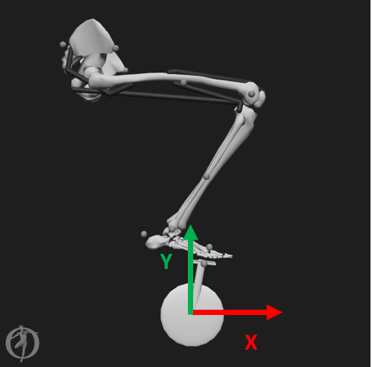

***Figure 1,*** *The fore-aft distance (red) from the bottom bracket to the center of the pelvis is the x-coordinate for the saddle position. The vertical distance (green) from the bottom bracket is the y-coordinate. The values of these two coordinates are what define the parametrized saddle position.*

We seek to analyze the effects of changing saddle position (as the parameterized input), and metabolic energy expenditure rate (as the output) with the computational biomechanical software, OpenSim. We will use a simplified musculoskeletal (with Hill-type muscles) model to determine the dynamics and metabolic energy expenditure rate for different saddle positions.

To our knowledge, there does not exist a ready-to-use computational model capable of measuring total lower body muscle activation energy expenditure rate for a cycling simulation, although other groups have looked to investigate energetics in other forms of moment[4][5][6][13][14][15] or related relationships in cycling[2][7][8][9][11][12][16][17][18] which we will explain in detail in the next section, related work.

Our overarching goal is to find the optimal saddle position(s) for which metabolic energy expenditure rate is minimized. We will use OpenSim to develop a workflow which maps an input saddle position (X, Y) (Figure 1) to an output of muscled-based metabolic energy expenditure rate (reported in Watts). Our primary goal is to evaluate and map saddle position to metabolic energy expenditure rate data in OpenSim for a simplified 1-leg cycling musculoskeletal model. Our subsequent goal is to develop an increasingly complex musculoskeletal model (incorporating lower-leg musculature, 2 legs, torque profiles) to more accurately study the relationship between saddle position and metabolic energy expenditure rate, in the form of more realistic pedaling motion, constraints, and anatomy.

# Related Work

OpenSim has been extensively used in research and industry as a biomechanics modeling tool to track motion and metabolic efficiency since 2007, when Dr. Scott Delp and his team first released the software to the world as an open-source science tool. Dr. Delp’s research group at Stanford has published several papers in this realm, mostly from their robust walking models in relation to metabolic consumption. Their 2017 study showed how OpenSim can be used to simulate ideal assistive walking devices with the goal of reducing the metabolic cost for these subjects [5]. The software’s built-in Computed Muscle Control (CMC) Tool, which is a key step in our workflow, solves for the model’s muscle excitations in for a given motion (i.e. set of kinematics). This CMC Tool output was then used to estimate metabolic energy consumption. We found that several other Stanford publications related to metabolic efficiency of walking and running also heavily depended on results from the CMC Tool[13][14][15].

Some researchers (outside of Dr. Delp’s group) have published data on OpenSim cycling mechanics that resonate more with our problem definition. In 2008, a master's student from Ball State University modified a common two-legged model on OpenSim to represent a cycling motion in order to measure metabolic output as a function of cleat placement on the pedal[7]. Other researchers have shown that changing the hip joint angle, which is altered by changing the saddle position with respect to the bicycle bottom bracket, has been proven to affect metabolic energy, power, muscle activation, and overall body kinematics[2]. Changes in aerodynamic drag based on seat position has proven to be a significant player in affecting overall cyclist efficiency[2], which is not being considered in the scope of this project but may be added later by Specialized. This is a possible area for additional future investigation. We further identified several other instances of muscle activation and joint angle experiments to add to our collection of cycling subjects[16][17][18]. It is important to note that these data were professionally extracted from a series of empirical trials with expert cyclists, utilizing electromyography to evaluate and validate muscle excitation as estimated by modeling as well as motion capture technology to measure joint angles.

In addition to the metabolic energy expenditure rate that can be extracted from the OpenSim model, we can gain valuable insights from which points during the cycling motion the muscles minimize energy based on their fiber lengths and fiber velocities (fiber velocity being defined as speed of muscle fiber contraction). These muscle states are derived completely from the kinematics and are unaffected by muscle activation, as seen in Equation (1). Together with muscle activation, these quantities are used to calculate the force generated from the muscle-tendon unit. [21]

(1)

The muscle force, *FM(t)*, is generated as a function of the maximum isometric muscle force, *FOM* , the muscle activation *a(t)*, normalized muscle fiber length, *(t)*, normalized muscle fiber velocity, *(t)*. Normalized fiber length and normalized fiber velocity are translated to fractions of maximum force output with the muscles’s physiological active force-length curve   
*(f L)*, force-velocity curve *(f V)*, and passive force-length curve *(f PE)*. The quantification of muscle activation is wholly contained in the parameter *a(t)*, which is defined on a range between 0 and 1, for completely lax and maximum activation respectively.[21]

Both Sebastian Bohm and Julian Alcazar’s research groups proved that these force-length and force-velocity relationships are highly correlated to metabolic energy expenditure rate based on experimental testing.[22][23] These studies paved the way for analysis of energy economy in movement guided by muscle force-length and force-velocity curves. Furthermore, Brian Umberger and his team used these muscle states in developing and validating a comprehensive human muscle energy expenditure model with the intention that this model could be used “in conjunction with forward dynamic computer simulations”[24] Umberger’s modeling of metabolic energy expenditure was incorporated into the OpenSim Application Programming Interface (API)[20] and will be used moving forward in this project to determine how saddle height is related to cyclist energetics.

Our team leveraged an existing, simplified model from the 2018 ME485 project course (Modeling and Simulation of Human Movement) at Stanford [19] as a starting point to which we could add complexity and detail. This group of students developed an educational cycling model for the purposes of getting high school students excited about biomechanics. It is a simple model, with only four muscles in the upper leg (i.e. no below-the-knee musculature), fixed foot-to-pedal constraints, and a fixed pelvis location. The ME485 group was able to generate a set of functioning forward dynamics but it only relies on the assumed, prescribed activation of two muscles to drive motion. Our team will use and build upon this model as a starting point to develop more robust and realistic cycling kinematics, dynamics, and energetics in OpenSim.

# Problem Context

The bicycle is referred to by many as the most efficient mode of transportation [3], where efficiency is defined as the ratio of mechanical power output at the bicycle wheels to the metabolic energy expenditure rate of the rider. By determining the methods to theoretically maximize rider efficiency, cyclists can incorporate this knowledge into their own cycling and maximize their performance. Based on our research, there does not exist a ready-to-use workflow incorporating computational tools or simulation software capable of quantifying metabolic energy expenditure rate as a function of saddle position. Our goal is to establish such a workflow using OpenSim software for our industry partner, Specialized, so that they can incorporate these simulations into their design cycle to make design changes to bicycle fit geared towards maximizing cycling efficiency.

# Workflow Description

Figure 2 illustrates the workflow we follow to collect metabolic energy expenditure rate data. We select a fore-aft distance (x-coordinate) and vertical distance (y-coordinate) for the saddle with respect to the bicycle bottom bracket and set constraints on our model coordinates. These constraints are implemented as restricting the movement of certain joints and bodies of the model leg. An example is locking the orientation of the pelvis to simplify the motion of the model. We also impose a “PedalClip” constraint which sets the xyz-position of the midfoot to equal the xyz-position of the crank pedal plus some fixed offset, so that it does not lift off the pedal at any point during the simulation.

Once the saddle position is selected, we perform Simulated Forward Kinematics on our model. The data that is collected from this step is functionally similar to the type of data one would collect from a motion capture experiment in a human performance lab. This simulation allows us to capture data such as joint angle trajectories as the model performs a desired movement. We prescribe a linearly increasing function for the crank angle, which enforces a constant angular velocity for the crank, and record the joint angle trajectories as the model leg passively follows along in a pedaling motion. Not only does this give us a set of joint angle trajectories, **Qn**, to input as desired kinematics for the Computed Muscle Control Tool, but we can also record muscle lengths, **Ln**, muscle velocities (speeds of contractions), **Vn**, and the reaction forces on the midfoot caused by the PedalClip constraint, **Fn**. The columns matrix **Qn** corresponds to each model coordinate such as pelvis_tilt, knee_angle, hip_adduction, etc., and the rows are values of those coordinates at different timesteps during the simulation. The columns of the muscle length and muscle velocity matrices, **Ln** and **Vn** respectively, correspond to each of the muscles included in the model. The columns of the external force matrix **Fn** correspond to x, y, and z components of the force vector acting on the midfoot. These data are used to inform the Computed Muscle Control tool in the next step of our workflow.

Computed Muscle Control is an algorithm for solving the inverse dynamics problem of computing the muscle activations required to initiate and track the motion observed in Simulated Forward Kinematics. The CMC algorithm accomplishes this in two main steps. First, a proportional-derivative control law (Equation (2)) is established to track a user-specified subset of desired coordinates (e.g. crank angle, knee angle). Computed Muscle Control then guesses a set of muscle activations that propagate the model

*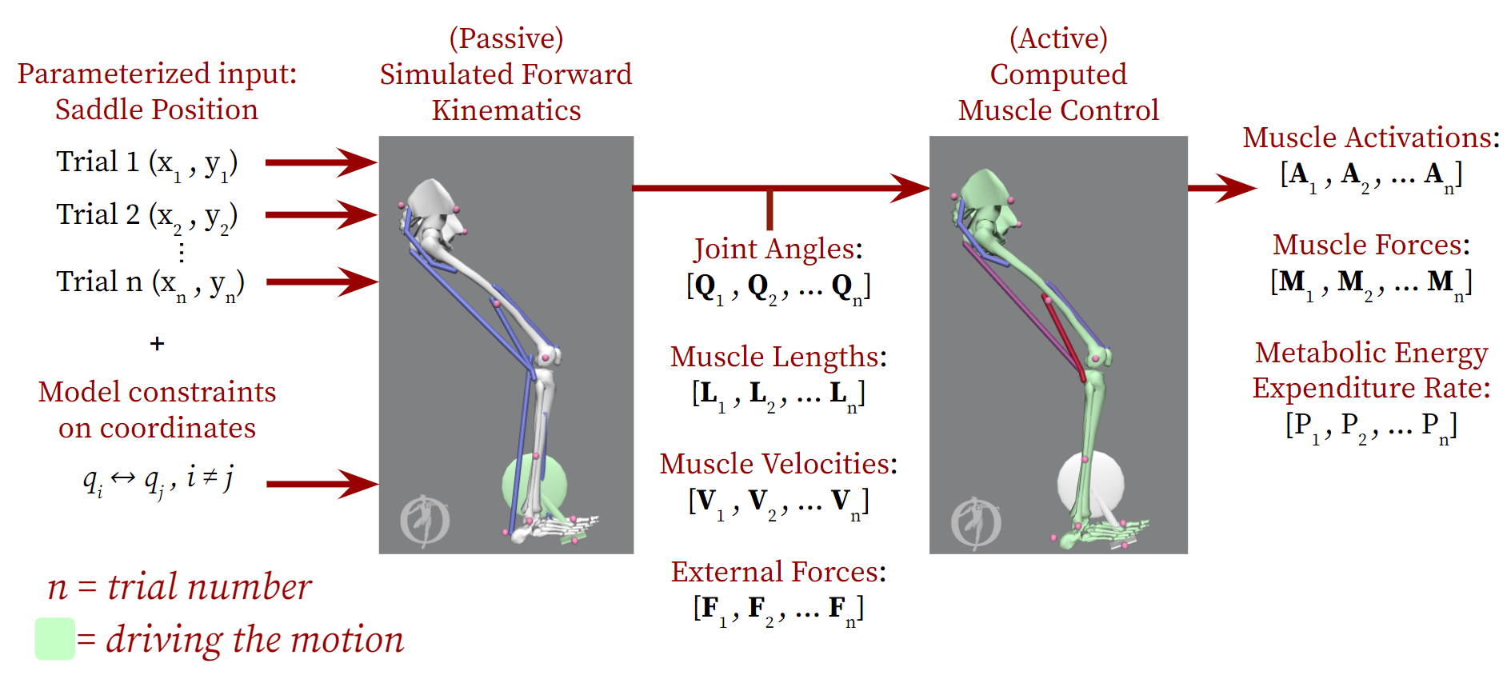****Figure 2****, Iterative Mapping Process Workflow. Mapping from Seat Position to averaged Metabolic Energy Expenditure Rate: . A saddle position is specified, constraints on certain coordinates for the model are imposed, and a single value representative of metabolic energy expenditure rate is computed. The Simulated Forward Kinematics step plays the role of experimental motion capture for the selected saddle position and is used to inform the Computed Muscle Control Tool. The Computed Muscle Control step calculates a set of muscle activations that enforces the model to reproduce the desired motion of Simulated Forward Kinematics. From the Computed Muscle Control Tool output, the metabolic energy expenditure rate of the muscles utilized for the movement is calculated.*

forward in time, and the resultant kinematics are compared to desired kinematics (desired kinematics being a set of joint angles usually collected from motion capture experiments).

(2)  
Second is the optimization process, where CMC is also minimizing an objective function, *J*, of Equation (3) that is proportional to the magnitude of muscle excitations and joint angle errors.   
** (3)

|  |  |
| --- | --- |
|  | desired (input) accelerations  for the j-th coordinate [] |
|  | model accelerations  for the j-th coordinate [] |
|  | coordinate weights [] |
|  | muscle excitations / actuator controls  for the i-th actuator [dimensionless] |

The muscle excitations for any timestep are recalculated a few thousand times or until the objective function converges to a minimum value.

A large part of the work that goes into running the Computed Muscle Control simulations is the adjusting of coordinate weights and at times, adjusting the constraints of the CMC model leg; the latter is somewhat aggressive but can be necessary to find a solution for the entire simulation time.

When the CMC simulation successfully finds a solution for muscle activations, we can then extract active muscle forces and metabolic energy expenditure rate for all muscles in our model.

# Complete Analysis for One Case

Given the workflow described above, we set out to explore a range of saddle positions by varying the distance in the x-direction and y-direction of the pelvis with respect to the bottom bracket. To establish repeatability of our output analysis and to visualize the initial data, we explored a smaller range: from -0.216 m to -0.236 m in the x direction and a range from -0.79 m to -0.91 m in the y direction. This range was selected from the initial starting position of the model: (-0.226 m, 0.8 m). By varying x and y coordinates by a step of ±0.01 m , we can begin exploring a family of positions. These ranges yielded 9 distinct combinations of x and y distances to form 9 distance positions of the pelvis location with respect to the bottom bracket. Consequently, 9 trials were run using the workflow described previously.

After generating this set of 9 saddle positions, we proceeded in our workflow to the Simulated Forward Kinematics step. This involved creating a new model file for each saddle position and generating the set of joint angles, muscle lengths, muscle velocities, and reaction forces via the Simulated Forward Kinematics. In this process, we came across 1 data point, (-0.236, 0.79), which was not able to output Simulated Forward Kinematics results. We believe this is due to the constraints at the foot and the length of the model’s leg. Visually, we observed the leg reach its maximum extension at the knee and therefore being unable to complete the end of the downstroke into the upstroke. Further examination will be conducted before moving forward to precisely explain this incompletion. As a result, moving to the CMC step of our workflow, we only had 8 saddle positions with data.

We were able to take these outputs and plug them into the CMC solver. We created 8 unique model geometry files to represent the change in saddle position (and relative joint angles) and ran the CMC solver using the corresponding kinematics and reaction forces at the pedal from the Simulated Forward Kinematics step. Each completed run required a multitude of adjustments of the tracking tasks and weights for various degrees of freedom throughout the model. This was unavoidable and required to ensure a completed CMC run for certain saddle positions. This is because the slightest changes in geometry cause discrepancies with the CMC tool solver. OpenSim’s CMC tool was not created for parameterizable studies, but rather based on one set of data for a subject-specific study with a one-time set of motion-captured kinematics. A replacement for the CMC tool is currently the project of a PhD student in Delp’s lab and may be an area for future work for projects such as the present project. As shown in Table 1, there is not a clear underlying pattern indicating which CMC trials required unlocked coordinates to run successfully and which did not. As arbitrary as this process is, it is the reality of working with OpenSim, a non-commercial, research based tool.

***Table 1****. Pelvis_tilt and Pelvis_list degrees of freedom (DOF) constraints during the run of the completed CMC trial for each of the 8 saddle positions do not indicate a clear pattern.*

|  |  |  |
| --- | --- | --- |
| Saddle position | Pelvis_tilt locked? | Pelvis_list locked? |
| (-0.236, 0.8) | Yes | Yes |
| (-0.236, 0.81) | No | No |
| (-0.226, 0.79) | Yes | Yes |
| (-0.226, 0.8) | Yes | No |
| (-0.226, 0.81) | No | Yes |
| (-0.216, 0.79) | No | No |
| (-0.216, 0.8) | No | No |
| (-0.216, 0.81) | No | No |

With the completed CMC trials from each saddle position, various outputs like muscle activations, muscle forces, and metabolic energy expenditure rates were obtained and stored.

From the workflow outputs, we are primarily interested in the total metabolic expenditure rate and have generated figures representing the data from the 8 trials. OpenSim’s CMC Tool outputs a tab delimited file describing the energy expenditure rate in Watts of each probed muscle in our model over the time steps of the CMC simulation. From this file, it is possible to visualize the maximum energy expenditure rate of the system (from the ‘metabolics_TOTAL’ column in the raw output file) for each of the 8 trials and plot it in a 3D graph with MATLAB.

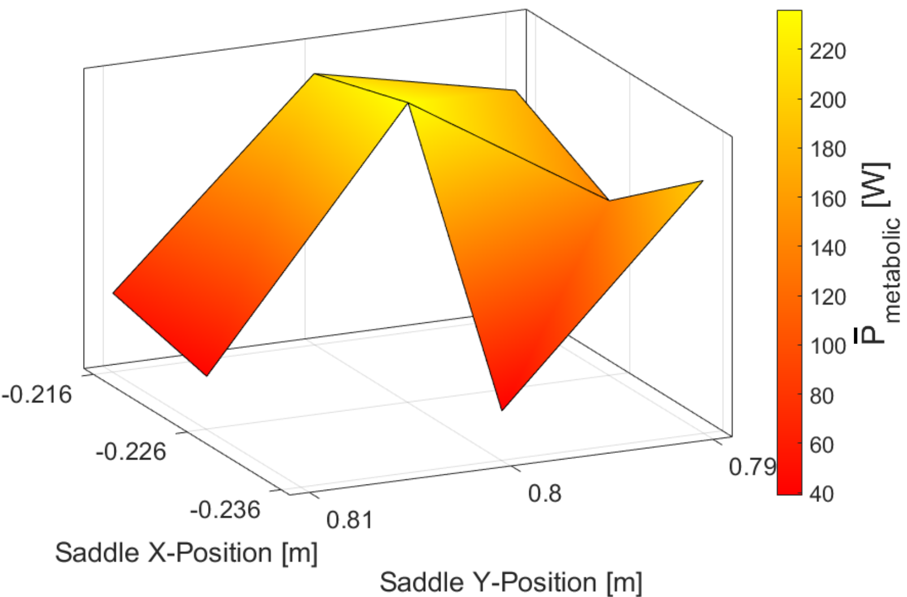

***Figure 3****, The 3D mapping of the relationship between saddle position (x, y), and the average total metabolic energy expenditure rates for each of the 8 saddle positions. For each trial, the total metabolic energy expenditure rate across all muscles was averaged and reported as a single scalar value for that trial.*

As we can see from Figure 3, the output is not exactly what we anticipated. This is most likely due the static optimization problem that the CMC solver works on behind the scenes, which will be explained further at the end of the analysis.

In Figure 4, we observe the metabolic energy expenditure rates for each of the muscles for the duration of a particular CMC simulation. The quadricep vastus intermedius muscle dominates the energy consumption of the model and is the main driver of the pedaling motion. The long head of the biceps femoris slightly contributes to the motion, but not enough to significantly influence the overall energy expenditure rate of the movement. These effects can be visualized by the size of the muscles’ peaks in Figure 4. The other included muscles are not highly activated and expend very little energy relative to the two aforementioned muscles.

Furthermore, we plotted and analyzed the metabolic expenditure rate of the vastus intermedius muscle, one of the quadriceps, across all 8 trials over time (Figure 5). The vastus intermedius muscle drove the majority of the motion, producing the most force, and therefore dominated the metabolic energy expenditure rate.

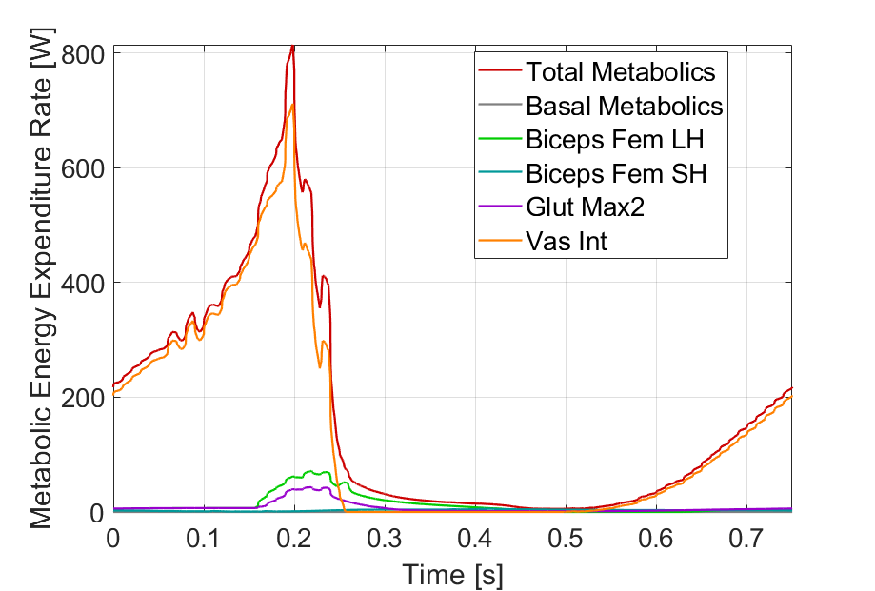

***Figure 4****, Metabolic expenditure data for all muscles from Trial: X=-0.216m Y=0.80m. The majority of the energy expended by the model is used to activate the quadricep vastus intermedius muscle as seen by the high peak. Biceps Fem LH = biceps femoris long head; Biceps Fem SH = biceps femoris short head; glut max2 = gluteus maximus; vast int = vastus intermedius.*

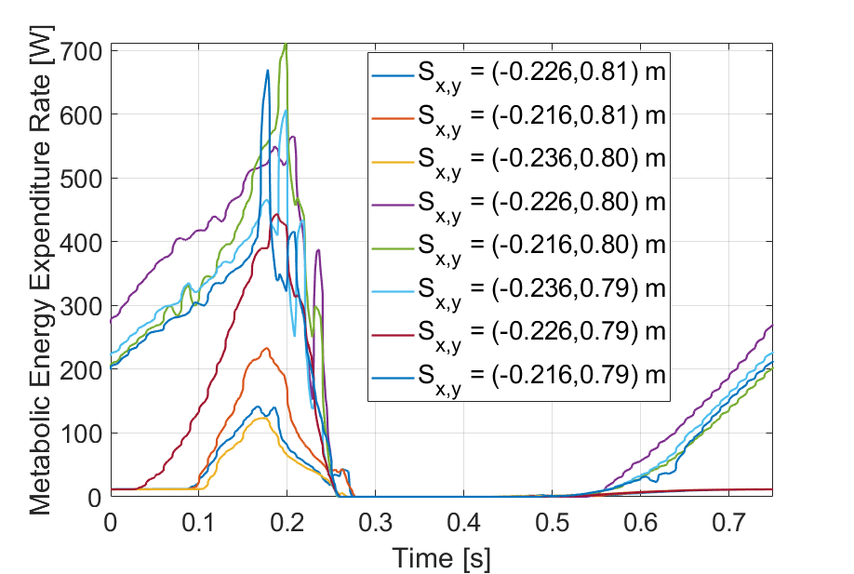

***Figure 5****, Metabolic expenditure profile for all 8 trials of the vastus intermedius muscle for one full cycling cycle. All trials show peak metabolic energy expenditure rate around t=0.2s which corresponds to the end of the cycling downstroke.*

The conclusions drawn from Figures 4 and 5 may be somewhat obscured by the noisy data. The variation in muscle metabolic energy rates’ trends and peaks among trials, as seen in Figure 5, can be explained by the CMC settings that required changes in between runs in order for the OpenSim CMC Tool to find *any* solution. This may have led to unbalanced comparison between trials. These settings sometimes required quite a bit of change between trials due to the large number of constraints on the movement allowed by the model. This led to pitfalls in the static optimization step of the solver where it carries out gradient descent optimization. These kinds of optimizations require stochastic initialization of the start position for potential solutions. That means the initial guess is effectively random, implying that the solution may not always converge at the same global minimum for the objective function of muscle activations and desired kinematics but instead may converge towards other local minima. This means, each trial potentially found different local minima to converge at and we cannot assume they converged at the global minimum, which may be more comparable across trials.

In machine learning, the classic way to avoid local minima is to use randomization, but there is no way to guarantee that every time we would get the global minimum solution. Figure 6 shows how random initialization can lead to convergence at local minima and global minimums.

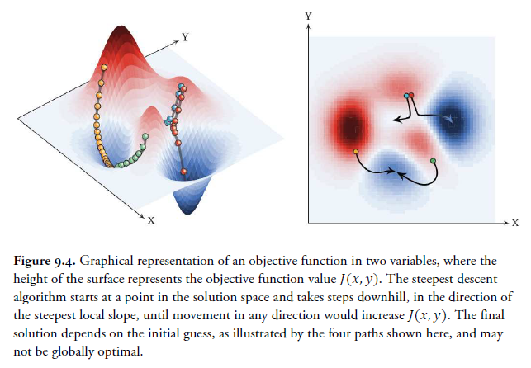

***Figure 6****, Computed Muscle Control gradient descent optimization. Contours show pathways for solution searching. Depending on the start position for the search, the solution converges to different minima where some are local minima and others are the global minimum.* [1]

Currently, we believe our cross trial comparisons are very likely comparing local minima solutions for certain trials against global minimum solutions for other trials. This is not ideal and in our next steps, we will be looking to avoid (or at the very least, decrease the negative impact of) this static optimization pitfall of local minima.

# Discussion: Ideas to Explore

As we continue to implement our main workflow and verify the results (described in the section above), it is equally important to broaden the scope of our design and analysis space in parallel. Over the first seven weeks of this project, we have uncovered a plethora of insights regarding the relationship between saddle height and metabolic expenditure rate, driven by our expanded comfort with using OpenSim as a biomechanics simulation tool. For the remainder of the project and for future Specialized studies, we have consolidated the following set of ideas to explore, along with their implications on the overall problem.

**Two-Leg Model**

Our current OpenSim workflow depends only on the metabolic expenditure rate of a single cycling leg, but there is a possibility to expand the motion and analysis to a second leg with out-of-phase movements. Specialized may benefit from this increase in complexity since it would allow for us to more accurately model the coupled motion between the two legs. This captured dependency will undoubtedly impact cycling kinematics and forces, two of the important inputs to the CMC Tool, which enables us to calculate metabolic energy expenditure rates. In the long run, with two legs in the model, Specialized can also more easily transfer motion capture data from experimental trials directly into OpenSim for post-processing. Because our OpenSim model depends so heavily on many constraints throughout the entire leg, creating this improved model is not as simple as copying every joint over the central plane, and instead requires detailed kinematics analysis. The Computed Muscle Control Tool additionally struggles to handle an increased number of degrees of freedom and might fail to find a robust solution. These are major drawbacks to this two-leg model idea so we hope to develop a barebones version over the next couple of weeks that can be leveraged by Specialized in the future.

**Resistance Torque**

Another limitation in our current OpenSim cycling model is the unrealistic nature of the bike crank. Currently, the model uses a prescribed motion and its own inertia to complete a full pedaling revolution and generate a set of reaction forces at the pedal in the Simulated Forward Kinematics step of our workflow. But the rider in the model experiences no pedaling resistance from the crank that would normally inhibit their pedaling kinematics, pedaling forces, and overall metabolic expenditure rate. We see this exploration path as another way to increase the complexity and practicality of our model. Especially since cyclists change gears along the duration of their ride, we would like to provide a method in which a resistive torque can easily be applied to and retracted from the model. From our literature review, we have even identified common resistive torque profiles at the crank which we will apply to our model at the calcaneus joint [27]. One drawback we predict is that to achieve robust analysis, the input torque profile depends on the construction of the particular bike and the biomechanics of the particular rider.

**Male vs. Female Cyclists**

Aside from implementing relatively minor changes to our current cycling model, we also believe that our OpenSim model can highlight the impact of the biomechanical differences inherent between male and female cyclists on metabolic expenditure rate.

As this project develops outside of the confines of a 10-week course, it is important for Specialized to run experimental trials for a wider demographic of users and capture any trends in order to design better bikes for all genders. The muscle properties and joint angles (due to varying Q angles as seen in Figure 7) can be manipulated in OpenSim to correspond to a particular rider, while keeping the remainder of our workflow constant, thus resulting in slightly different kinematics. Women have larger Q angles and thus their knee ligaments experience higher loads than their male counterparts. Therefore, this exploration area could potentially optimize saddle height in order to minimize risk of injury for female cyclists[28]. A limitation we see with this line of research is the minimal literature available for female cycling biomechanics at this time.

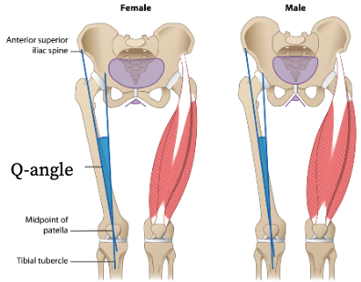***Figure 7,*** *Definition of Q-angle for female and male anatomy. Q-angle is defined as the angle between the hip and the knee. The Q-angle is larger in females than males which increases the loading on the knee during most movements.*[28]

**Implications of Fatigue (Sprints & Endurance)**

While our current workflow is assuming a constant cadence pedaling stroke over a fixed period of time, another long-term idea we could explore is the implications of fatigue on metabolic expenditure rate. Riders who are either planning a long-distance ride or a series of short sprint exercises could drastically improve their overall performance with a streamlined analysis of their muscle fatigue. This information could help cyclists understand how quickly their muscles recover from strenuous activation and, in turn, they can plan their rides more strategically. Fatigue is a concept that we have yet to explore on OpenSim but could present a workflow to Specialized for future investigations. There even exists an opportunity to validate these OpenSim fatigue results using electromyography (EMG) in the lab. One drawback we see with this exploration idea is the uncertainty of OpenSim to run long-term analysis trials for several hours in order to measure fatigue and recovery.

**Honorable Mentions**

In addition to the four ideas that we prioritized above, we generated an additional set of ideas that might also have the potential to have a large impact on the future of our project. These include applying aerodynamic drag forces to our model as a function of hip angle, modeling different cycling gaits such as out-of-saddle pedaling, modeling handlebars and varying their locations, and validating ground reaction forces with experimental data.

# Plan: Next Weeks

In the next weeks, we have 4 main focuses:

1. Minimize variability between CMC runs to be able to compare global maximum solutions across trials
2. Explore a broader family of saddle positions using literature studies of ideal saddle position to focus our search space.
3. Explore and document how muscle states outputs of forward kinematics step in the workflow align with Specialized’s development goals, without needing to use the CMC Tool
4. Add complexity to the model in reality-maximizing ways (i.e. adding muscles for the lower leg, creating a 2-leg model, adding resistance torque to the pedal forces to simulate terrain/bike related work)

**Local Minima Convergence**

For the first goal, the problem of the local vs global minimums described in the analysis section does not have a straightforward solution. However, we do have a potential path of exploration going forward. We have decided to explore adjusting the CMC tool optimization convergence tolerance, integrator step sizes, and derivative step sizes. These can potentially affect our CMC simulations to be more consistent in converging to the global minimum in most cases, but cannot eliminate the issue entirely. The typical method to address convergence variability in machine learning and optimization is to run many trials for each setting. For example, with our saddle position inputs, that would mean running *thousands* of *completed* CMC simulations for each (x1, y1) position, to be able to find the global maximum for 1 data point. Then we would move onto the next saddle position data point (x2, y2) and again, run thousands of *completed* CMC trials to find *its* global minimum. After obtaining each saddle positions’ global minimum solution, we would be able to more effectively compare the metabolic energy expenditure rate data.

Unfortunately, this process is something OpenSim was not designed to handle as achieving *just 1* completed CMC simulation takes many manual adjustments of CMC tracking tasks and weights to find the right combination that will achieve a completed solution. There may be external ways of coordinating this and automating this process in a more systemized fashion but OpenSim currently does not have those abilities built in.

**Literature Informed Saddle Positions**

For the second goal, the current family of saddle positions we have explored are based around the initial model position. In the next few weeks, we will explore ‘families’ of positions based around saddle positions that have been studied in other cycling research. ‘Families’ of positions indicates a collection of positions in a neighborhood that vary slightly outside the range of the start position (varying in the positive x, y direction and varying in the negative x, y directions). This will allow us to compare our results to other studies and slowly build a mapping of energy expenditure rate to saddle positions starting with the most relevant positions.

**Muscle States**

For the third goal, we have determined that Specialized is very interested in the use of muscle states (force-length relationship, force-velocity relationship) to inform bike design. As mentioned previously in the related works section, muscle forces can be calculated from muscle properties and simple kinematic motion from the Simulated Forward Kinematics workflow step. Furthermore, it is proven that force-length and force-velocity relationships of muscles are highly correlated to energetic cost. When muscle force is maximized, metabolic energy expenditure rates are minimized because the muscles are stronger at these times and do not need to work as hard to produce forces sufficient for movement. Understanding this, it is possible to provide Specialized with the information they need about potential energy expenditure of muscles when cycling based on saddle position without the use of the CMC Tool. In the next few weeks, we aim to fully define what this intermediate workflow can provide as well as begin to correlate its outputs to CMC metabolic expenditure rate outputs. This can help validate if the intermediate outputs from our workflow are sufficient for Specialized’s applications.

**Adding Complexity**

Finally, for the fourth goal, we plan to continue incorporating elements (muscles, forces, other bodies) into our model to create a more complex and therefore more anatomically realistic model. This work, though ultimately less useful for Specialized’s immediate applications, provides the groundwork for future research in modeling cycling through simulation. The documentation created in the pursuit of this goal will enable future researchers to continue the work in exploring the limits of modeling cycling metabolics through OpenSim.

# 

# References

[1] Uchida T, Delp, S. *Biomechanics of Movement,* (2020)

[2] Faulkner, S. and Jobling, P. *The Effect of Upper-Body Positioning on the Aerodynamic-Physiological Economy of Time-Trial Cycling.* International Journal of Sports Physiology and Performance, (2020).

[3] Dodge, David. *The Most Efficient Transportation On the Planet*. Huffington Post Online (2013).

[4] Koelewign, A. D. et al. *Metabolic cost calculations of gait using musculoskeletal energy models, a comparison study.* PLOS ONE 14(9): e0222037, (2019).

[5] Dembia CL, Silder A, Uchida TK, Hicks JL, Delp SL *Simulating ideal assistive devices to reduce the metabolic cost of walking with heavy loads.* PLOS ONE 12(7): e0180320, (2017).

[6] Jackson, R. W. and Collins, S. H. *An experimental comparison of the relative benefits of work and torque assistance in ankle exoskeletons*. J Appl Physiol 119: 541–557, (2015).

[7] Leib, D. *The Effects of Clear Placement on Muscle Mechanics and Metabolic Efficiency in Prolonged Sub-Maximal Cycling*. Ball State University Biomechanics Laboratory Thesis, (2008).

[8] Pottinger, M. *Inverse Dynamic Analysis of ACL Reconstructed Knee Joint Biomechanics During Gait and Cycling Using OpenSim*. California Polytechnic State University, San Luis Obispo Thesis, (2018).

[9] Coleman DA, Wiles JD, Davison RC, Smith MF, Swaine IL. *Power output measurement during treadmill cycling*. Int J Sports Med. ;28(6):525-30, (2007).

[10] Peveler, W. and Green, J. Effects Of Saddle Height On Economy And Anaerobic Power In Well-trained Cyclists. National Strength and Conditioning Association , Vol 25, 3, (2011).

[11] Hull, M.L. and Jorge, M. *A Method For Biomechanical Analysis of Bicycle Pedalling*. Journal of Biomechanics Vol 18 No 9. pp 631-644, (1985).

[12] Gonzalez, H. and Hull, M.L. *Multivariable Optimization of Cycling Biomechanics*. Journal of Biomechanics Vol. 22 No 11/12 pp 1151-1161, (1989).

[13] Uchida TK, Seth A, Pouya S, Dembia CL, Hicks JL, Delp SL (2016) *Simulating Ideal Assistive Devices to Reduce the Metabolic Cost of Running*. PLoS ONE 11

[14] Uchida TK, Hicks JL, Dembia CL, Delp SL (2016) *Stretching Your Energetic Budget: How Tendon Compliance Affects the Metabolic Cost of Running*. PLoS ONE 11

[15] Hamner, Samuel R, Delp, Scott L. *Muscle contributions to fore-aft and vertical body mass center accelerations over a range of running speeds*, Journal of Biomechanics, Volume 46, Issue 4, 2013

[16] Fonda, B., & Sarabon, N. (2010). *Biomechanics of cycling ( Literature review )*. Sport Science Review, 19(1), 187–210

[17] Ferrer-Roca V, Roig A, Galilea P, García-López J. *Influence of saddle height on lower limb kinematics in well-trained cyclists: static vs. dynamic evaluation in bike fitting*. J Strength Cond Res. 2012

[18] Bini RR, Tamborindeguy AC, Mota CB. *Effects of saddle height, pedaling cadence, and workload on joint kinetics and kinematics during cycling*. J Sport Rehabil. 2010

[19] Henrot, C and Jeffries, L. [*OpenSim Teaching Materials -- Educational Cycling Model*](https://simtk-confluence.stanford.edu/display/OpenSim/OpenSim+Teaching+Materials+--+Educational+Cycling+Model). BIOE-ME 485 Spring 2018

[20]*OpenSim::Umberger2010MuscleMetabolicsProbe Class Reference*. OpenSim API 3.3 Documentation (2015).

[21] Uchida, Thomas K., et al. Biomechanics of Movement: The Science of Sports, Robotics, and Rehabilitation. The MIT Press, 2021.

[22] Bohm Sebastian, [Mersmann Falk](https://royalsocietypublishing.org/author/Mersmann%2C+Falk), [Santuz Alessandro](https://royalsocietypublishing.org/author/Santuz%2C+Alessandro), and [Arampatzis Adamantios](https://royalsocietypublishing.org/author/Arampatzis%2C+Adamantios) (2019) *The force–length–velocity potential of the human soleus muscle is related to the energetic cost of running* Proc. R. Soc. B.286

[23] Alcazar J, Csapo R, Ara I and Alegre LM (2019) *On the Shape of the Force-Velocity Relationship in Skeletal Muscles: The Linear, the Hyperbolic, and the Double-Hyperbolic.*

[24] Umberger, Brian R., Karin G.M. Gerritsen & Philip E. Martin (2003) *A Model Of Human Muscle Energy Expenditure, Computer Methods In Biomechanics And Biomedical Engineering,*

[25] Bini, Rodrigo & Hume, Patria & Croft, James. (2011). Effects of Bicycle Saddle Height on Knee Injury Risk and Cycling Performance. Sports medicine (Auckland, N.Z.). 41. 463-76. 10.2165/11588740-000000000-00000.

[26] Wozniak Timmer, Cheryl A., MS, PT. (1991). Cycling Biomechanics: A Literature Review. Journal of Orthopaedic & Sports Physical Therapy. 14:3. 106-113.

[27] Quintana-Duque, J.C., Dahmen, T., Saupe, D., 2015. *Estimation of torque variation from pedal motion in cycling*. Int. J. Comput. Sci. Sport 14, 34–50.

[28] Pappas, E (2019) *Do Female Athletes get ACL injuries because of their ANATOMY?*

[29] Tsianos, George A, and Lisa N MacFadden. Validated Predictions of Metabolic Energy Consumption for Submaximal Effort Movement. PLoS computational biology vol. 12,6 e1004911. 1 Jun. 2016.